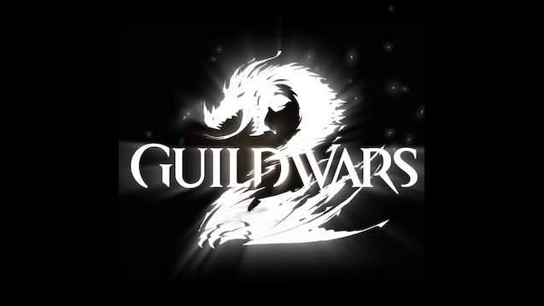

GUILDWARS 2 Verdant Brink Day & Night Guide

Things you need to know about Verdant Brink Day & Night.

By Flawless Equinox AKA Murmaid

Exodus/z of the elder dragons/z [GODS] (Leader)   EU based

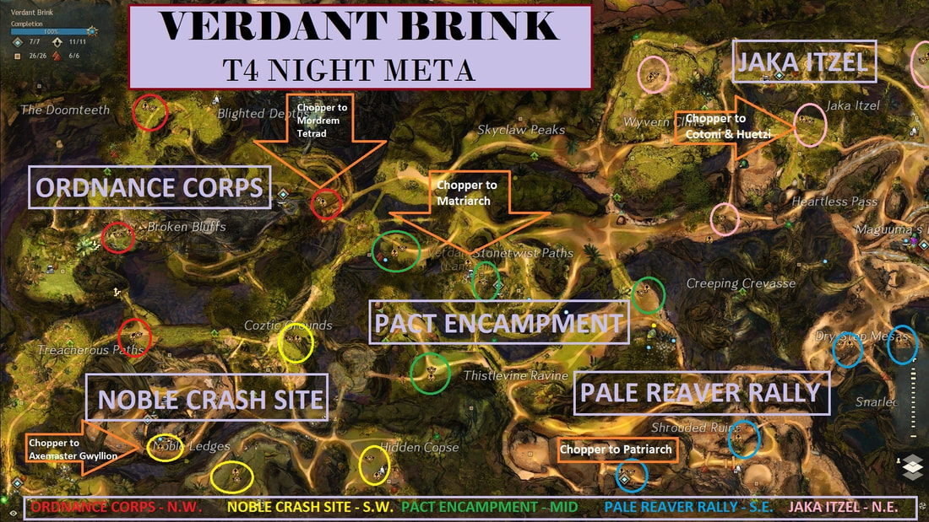

Need to mark -> The Camps in purple names

Rally Points -> those marked in Circles these need to be defended during night + upgraded

---------------------------------------------------------------------------------------------------------------------------------  
*Chat guide(day):*

We will do Day Pact Camp Outpost(Middle) first and after, if we have time, we will go to Faren and/or Frogs for Wyverns. During day you can follow me. Spread just if I say it is required.

If there is a specific camp you need, feel free to go & start it and get the progress up, make sure to stop collect event so we can all come.

Any Preference for Vote? Doc, Engi, or Master?, Achievement is called Equitable Elector – Have a look if you need to know which you need. No preference then vote Engi.

Take water from the naughty Dolyak Alfie ( He likes to misbehave), Throw it on fires and take parts to the others dolyak, save spare parts for 2nd collect.

Spread out between all 3 zones, we need the most people to go north ( Saurins ) as they are the hardest group of enemies to kill during this event, I will go mushrooms, no more than 3 with me.

We need to split between the 2 zones survivors have spawned and escort them, Cure Conditions and they will start to run making the event faster to achieve.

For this event, you need to zoom in & look for the red / green bar – Green = innocent / Red = traitor. Ask again if they are same. Talk to the NPC I Targeted to get the event shown.

*Squad Message:*

For night:

You have to spread all over the map and choose one untaken rally from the marked ones.

On each rally we need just 2-3 players, not more.

You have to defend the rally that you chose, bring supplies to it and do escort events!

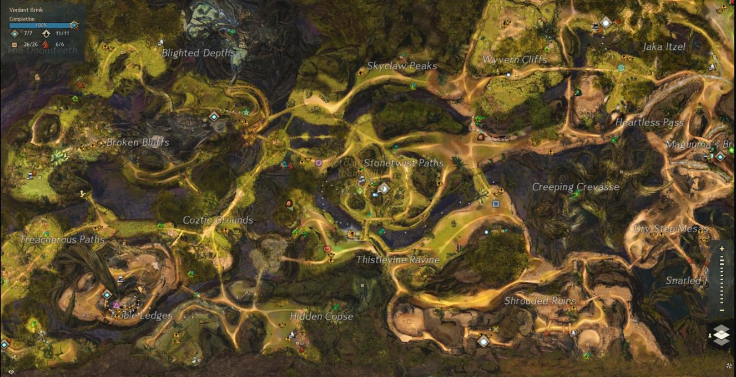

explain how the night meta works & how we get T4 easy, this will give you a [&AgEvJQEA] as reward.

For Night we need to defend rally points all around the map, and this will increase the tier level in order for us to get to T4

I also marked the other zone's main rallies. The main rallies corresponding to the night bosses are:

->**Matriarch** – [&BAgIAAA=] -arrow(green mark)

->**Axemaster** **Gwyllion** – [&BO8HAAA=] -star(green mark)

->**Patriarch** – [&BAEIAAA=] -X(yellow mark)

->**Cotoni** and **Huetzi** – [&BOAHAAA=] -spiral(cyan mark)

->**Tetrad** of Mordrem Champs – [&BMsHAAA=] -triangle(magenta mark)

Tips: You can teleport and use mount with the Pact Supplies. Escort are important and they are marked on the map with yellow circle with a soldier inside.

----------------------------------------------------------------------------------------------------------------------

1)First players need to choose one of the marked rallies and defend it when it is under the attack. Each rally need just 2/3 players so don't stack too many on a rally because we need to defend all of them.

You can also choose an unmarked rally if all marked rallies are taken. Also if you think that you can defend a rally alone it is recommended to choose an unmarked one.

Tip you can leave a mender alive & it should stop other mobs from spawning & makes it 10x easier for you.

2) You need to gather pack supplies and bring them back to the rally to level it up which takes 3-4 supplies to upgrade.

3) More important you need to do Escort Events that are marked on map with an yellow circle with a soldier inside. They are important for event progress and also they upgrade +1 your rally's tier.

You will also find some bosses in the map that are easy to kill and it is recommended to kill them. They also help getting more progress. Also you can retake the lost rallies.

Don't forget to come back to your rally when it is again under attack. Also if you need help with a rally tell on chat before you lose it. Same with escorts, if need help.

So all you need to do on the META Event, until choppers are down, is to choose a rally(that need just 2/3 players per rally), defend it, bring it Pact Supplies and do Escort Events.

Rallies defended, great job! Now go and search for Pact Supplies, do Escort Events and kill bosses that you meet.

Great job everyone, we did it! Now wait in the map for the prizes until xx:30. Don't leave the map! If you leave you won’t get reward at end sadly.